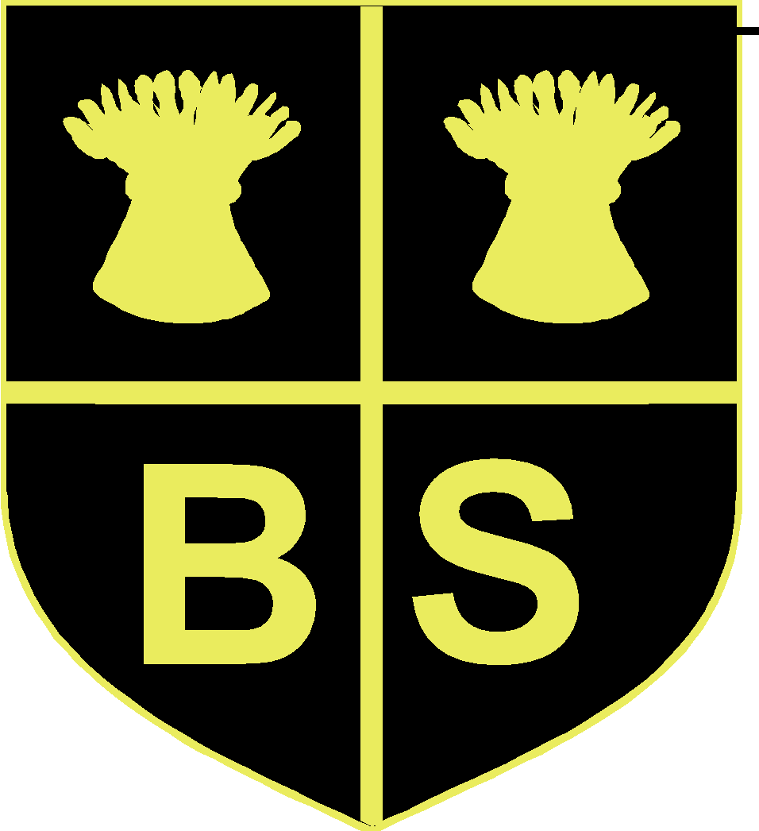
BARNSTON PRIMARY SCHOOL CURRICULUM EXPLANATION FOR PARENTS

At Barnston every minute of learning time counts, so we make sure that we provide children with a rich and varied curriculum to enhance their learning.

Our teachers plan together in phases (i.e. the two reception teachers, the three year 1/2 teachers, the three year 3/4 teachers and the three year 5/6 teachers). This means that they can plan to their strengths and share out subject expertise as well as helping each other to create differentiated resources and focused targets for the children, whilst ensuring the depth of coverage and the effective use of learning time.

Morning curriculum
During the course of the morning, KS1 and KS2 children will engage with mathematics, phonics, English and additional English sessions, though timings may vary:

Phonic groups (F2 & KS 1 age 4-7)

Early in the academic year, the children in the two F2 (reception) classes and the three Yr1/2 classes are all split into ability phonic groups. We call these groups phonic phases and the children work for half an hour on their segmenting and blending sounds with graphemes and phonemes and learn how to spell, write and read words.

Work is often very practical using Jolly Phonics actions in Foundation 2, different movements for different phonic blends, phonic games and the use of white boards to write down phonic attempts in a ‘do and show’ session with the teacher or teaching assistant. The children are split into phonic phase groups where phase 1 focuses on speaking and listening activities; phase 2 introduces individual letter sounds up to phase 5 and phase 6 which focuses on more complex spelling patterns for those who are advancing in phonics and need to be pushed at a higher level (reference separate phonic and reading information).

English (KS1 & KS2)

An English lesson where children will be working through different aspects of English relating to the National Curriculum levels for this age and/or ability group. We plan on a two year rolling programme and the children are taught at the stage that they are at, not their age (i.e. work is differentiated within the class to meet the children’s needs at the stage that they are at). It is important that English in F2 and KS1, follows the phonic phase work in order that they have opportunities to practise phonics skills during reading and writing tasks, thus creating transferable skills.
In KS2 (age 7-11) the children have approximately one hours English, where they will be learning grammar and punctuation, vocabulary building and the language or organisational features employed in different genres. They access a big write once every week or two depending upon the activities. Their writing is also enhanced in the creative curriculum where literacy standards are expected to be consistent.

Our cursive style handwriting is taught, continuing on from what the children learnt in reception and the stage that they managed to achieve. This is incorporated into literacy sessions and during morning registration (KS1 8.45-9.10 am).

The children have individual next step targets, which the teacher uses to help the children understand how to move on in their own learning. In KS1 this will mainly be oral feedback to a child from the teacher or teaching assistant. The teacher uses many assessment techniques, one of which is ‘two stars and a wish’ – two things I have done well and one thing I need to improve. Children can also assess their own work and the work of a peer. The teacher will look at their targets with them, look at the work they’ve just carried out and together they will decide if they have achieved their target.

It is important that children learn their spellings every week, understand the words in the context of a sentence and that they read every night at home.

Mathematics (F2, KS1 & KS2)

Foundation 2 access practical activities related to Number and Shape, Space and Measures. The areas are enhanced to challenge children in their learning. Children explore different ways of recording their findings and are encouraged to talk about and explain their mathematical processes.

In KS1 and 2, the children work in their classes or groups and the teachers work through the National Curriculum. The work is differentiated to the children’s ability within the class and the teacher works at the stage that the children are at, not their age (as some year 1 children may be working at the same level as some year 2 children and vice versa).

The curriculum incorporates mental strategies and problem solving activities and the lessons incorporate a mix of practical activity in pairs/groups and individual work to demonstrate understanding. All mathematics is constantly related to everyday life situations and mastering number bonds is very important at this age.

The children have individual next step targets which the teacher uses to help the children understand how to move on in their mathematical learning.

We expect the children to work on their times tables at school and at home as these form the foundation of all mathematics. They will have regular table tests (not necessarily formal testing) and should know their 2s, 5s and 10s in year 1 and in year 2 building on these by learning their 3s and 4s. Starting from different numbers and working both forwards or backwards in 2s (even or odd) and 10s is very important for securing number bond knowledge e.g. 33,35,37,39.41 or 13,23,33,43 or 79.69.59.49.39 etc. (reference parent information maths power points on the VLE and make sure you have a copy of our ‘Parent guide to teaching mathematics’, which we give out at the year 1 transition meetings in the summer term before they enter year 1).

In KS2 the children will be expected to learn at home their 6s, 7s and 8s (year 3) and be working towards their 9s and 11 and 12s by year 4. They should have mastered all tables by the end of year 4.

KS2 reading time (age 7-11)

This happens at the end of the morning and is a time where groups are rotated throughout the week and work on grammar and punctuation, guided reading sessions with the teacher working to the children’s individual targets, handwriting, vocabulary building, dictionary work, skimming and scanning skills, silent reading and note-taking skills. There are usually five activities that every child accesses throughout the week and the teacher responds to assessment e.g. If a class are all showing a lack of punctuation in the previous weeks writing tasks, a teacher may have one guided reading session per group per week and four punctuation activities. If this impacts on the children’s work the following week, the focus may then shift to grammar exercises.

F2 (reception)

As well as focused groups taken by the teacher and teaching assistant in mathematics and English, the classrooms are set up each week with continuous provision areas. The areas are specific to enhance the learning of the children and the teacher and the TA monitor and assess their learning within these areas throughout the week. The children are taught to think and work independently and activities challenge the children to aim high, no matter what their ability or starting points.

History/Geography 1.20pm-3.25pm (KS1 & 2)

History/geography are topic based e.g. Egyptians, Volcanoes, Vikings, Oceans etc. but history teaching focuses on historical enquiry, primary & secondary sources and artefacts and chronology, whilst geography focuses on place and locational knowledge, human and physical aspects and field/map work. The subjects incorporate many other subjects e.g. ICT, Science, Art, Design Technology and provides more opportunities for children to read, write and apply their mathematics and ICT to everyday situations. It also provides opportunities for them to use their problem solving skills. The children work individually or in collaboration with others and put their work together creatively in a history/geography book. Skills for life are developed as the children are encouraged to share and present work and ideas in groups and explain and give reasons for their decisions. The children are assessed through the National Curriculum key skills for history and geography. Many themed days (which involve parents) are planned throughout history and geography e.g. an evacuation day, rainforest exhibit and dinosaur museum – these days provide the children with a wider audience to show off their historical enquiry skills and geographical knowledge and skills.

Games/PE

Each class has 2 hours physical activity throughout the week. The teacher takes the class for half a term of PE and half a term of dance and John Jones of Ace of Sports partnership runs focused age related sessions focusing on developing skills in many different areas of games e.g. football, basket-ball, tennis, cricket, multi skills and swimming Y3-6. The subject lead and Mr Jones liaise regularly in order to maintain high standards and assessments are used in daily lessons. John Jones organises football at lunchtime with the Y5/6 and also takes many after school clubs and holiday clubs focusing on skills. Games lessons are challenging and competitive sports days are organised throughout the year and parents are invited to the last one in the summer term. Every afternoon playtime, KS2 walk or run the mile line for 10 minutes and we arrange many inter-school competitions throughout the year, particularly within the Federation.

ICT

In addition to ICT across the curriculum, each class can use the ICT suite to work on National Curriculum age related skills. These skills are then practised within the wider curriculum. Children have opportunities to use cameras, visualizers, chrome books, Ipads and audio visual aids to enhance this subject. E-Safety is promoted throughout the school and the children are regularly reminded of how to stay safe on-line, with tablets, computers and mobile phones in ICT lessons and in PSHE/circle times. The school has a service level agreement with Hi-Impact, who are timetabled to take classes across the school at various points throughout the year – this enables the children to programme robots, use raspberry pi equipment and green screen. We also have an ICT programming club which runs for 2 terms. The ICT lead regularly up-dates staff in staff meeting training and arranges for Hi-Impact further specialist training in lesson time – i.e. the teacher’s skills are enhanced and kept up-to-date by watching the specialists teach a specific aspect and this stops the ICT lead from having to leave his class too often.

PSHE/Circle time

Instead of a whole school assembly, each class has either a PSHE or a circle time once a week, where children discuss social, emotional and friendship issues. They discuss topics such as safety, bullying, racism, e-safety, homophobia (older children). This helps to remove any barriers to learning and encourages the children to talk about issues. The PSHE Associations scheme is referred to, although teachers plan to the needs of the class and cover issues and topics that may have arisen during the course of the day. Lesson planning takes account of any issues a teacher has observed, responds to current world issues and certain National or International events/days are incorporated into the curriculum.

Music

The music specialist uses Charanga Music system and enhances this with her own expertise throughout the age groups and is constantly using assessment in her lessons to enhance learning and provide greater challenge. All the children learn to read and write music and to play a tuned instrument and by KS2 pupils are reading and writing on the stave. Music is enhanced by our many visitors to school in assemblies/concerts, in-house and Federation concerts and through our peripatetic music teachers and our music clubs (choir, recorders and Musical theatre) available at lunch time and after school by the 3 music specialists. e.g. Philharmonic visit and school orchestra as well as events provided by Cheshire and Wirral Music hub.

Science

Our science is related to everyday situations and is taught every week for an afternoon. In 2014 our science lead completely re-wrote the science curriculum and incorporated assessment opportunities. This is continuously being improved, e.g. the science lead joined a Hi-Impact science project with regular meetings for science specialists to share the coherence of their curriculum and to make improvements – ICT was incorporated and used in Science Investigations. We have science clubs after school throughout the week and links to our local secondary school who provide specialist science instruction in the year. There is an annual science week held in the summer term to raise the profile of science across the school.

Art and Design Technology

These are subjects in their own right with specific skills and techniques taught but where possible are related to the history and geography curriculum and whole school art days are organised by the art specialist once a term, directing teachers to focus on different mediums and development and experimentation in order to practise skills. Art and DT tend to be blocked in days every half term, as this provides the children with time to focus and to give the subject the attention it deserves. DT focuses on designing, making and then evaluating their work and then making any improvements. Art and DT clubs are available as extra-curricular activities also.

Modern Foreign Languages

All our teachers speak basic French or Spanish and from 4-7 years old the teachers will teach the children to say hello, how are you, and some songs. In year 3/4 the children have 40 minutes Spanish a week with a specialist teacher and in year 5/6 they have 40 minutes Spanish a week with a specialist teacher. The teachers plan a balance of spoken, written and cultural language. Literacy, mathematics and ICT are also brought into the MFL curriculum where possible e.g. A year 5/6 class were learning to tell the time in analogue and then converting it to digital, but in Spanish!
In 2019 basic Mandarin has been introduced into KS1 classes through using China Box.

RE

A selection of religions are taught throughout each year group and we celebrate festivals from different religious backgrounds throughout the year in assemblies and PSHE class sessions. RE is taught for 1 hour/week and includes trips, visitors, practical activity, watching video clips, discussions/debates, moral activities and factual knowledge of the main religions, how they have similarities and differences and how they can all provide moral guidance.

