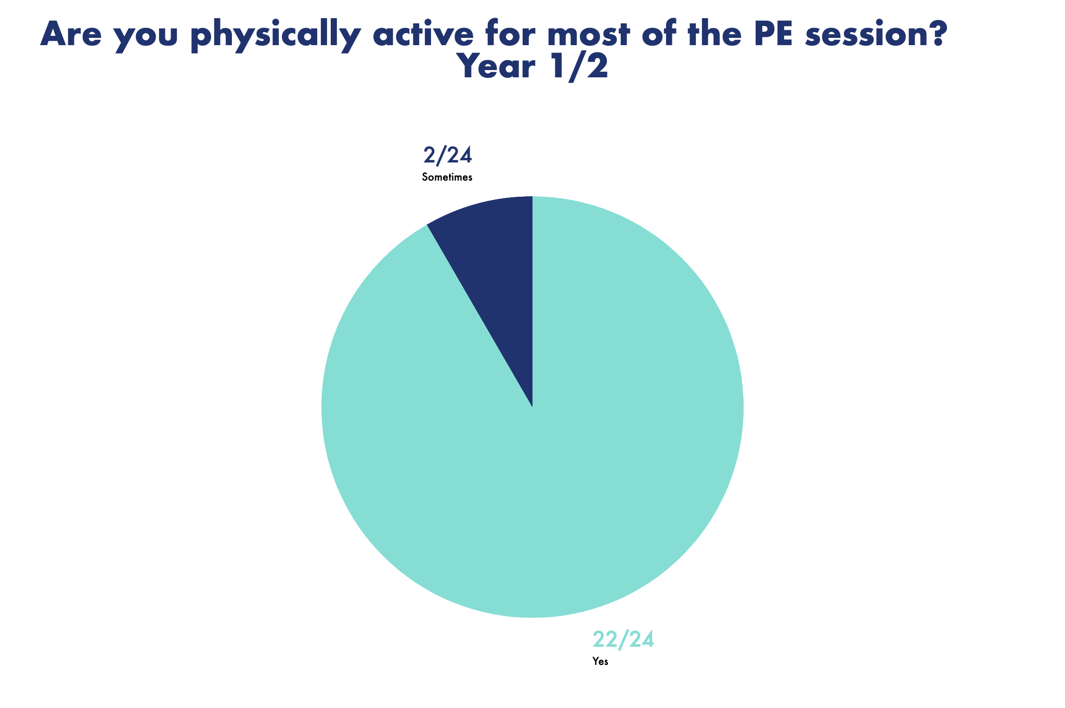
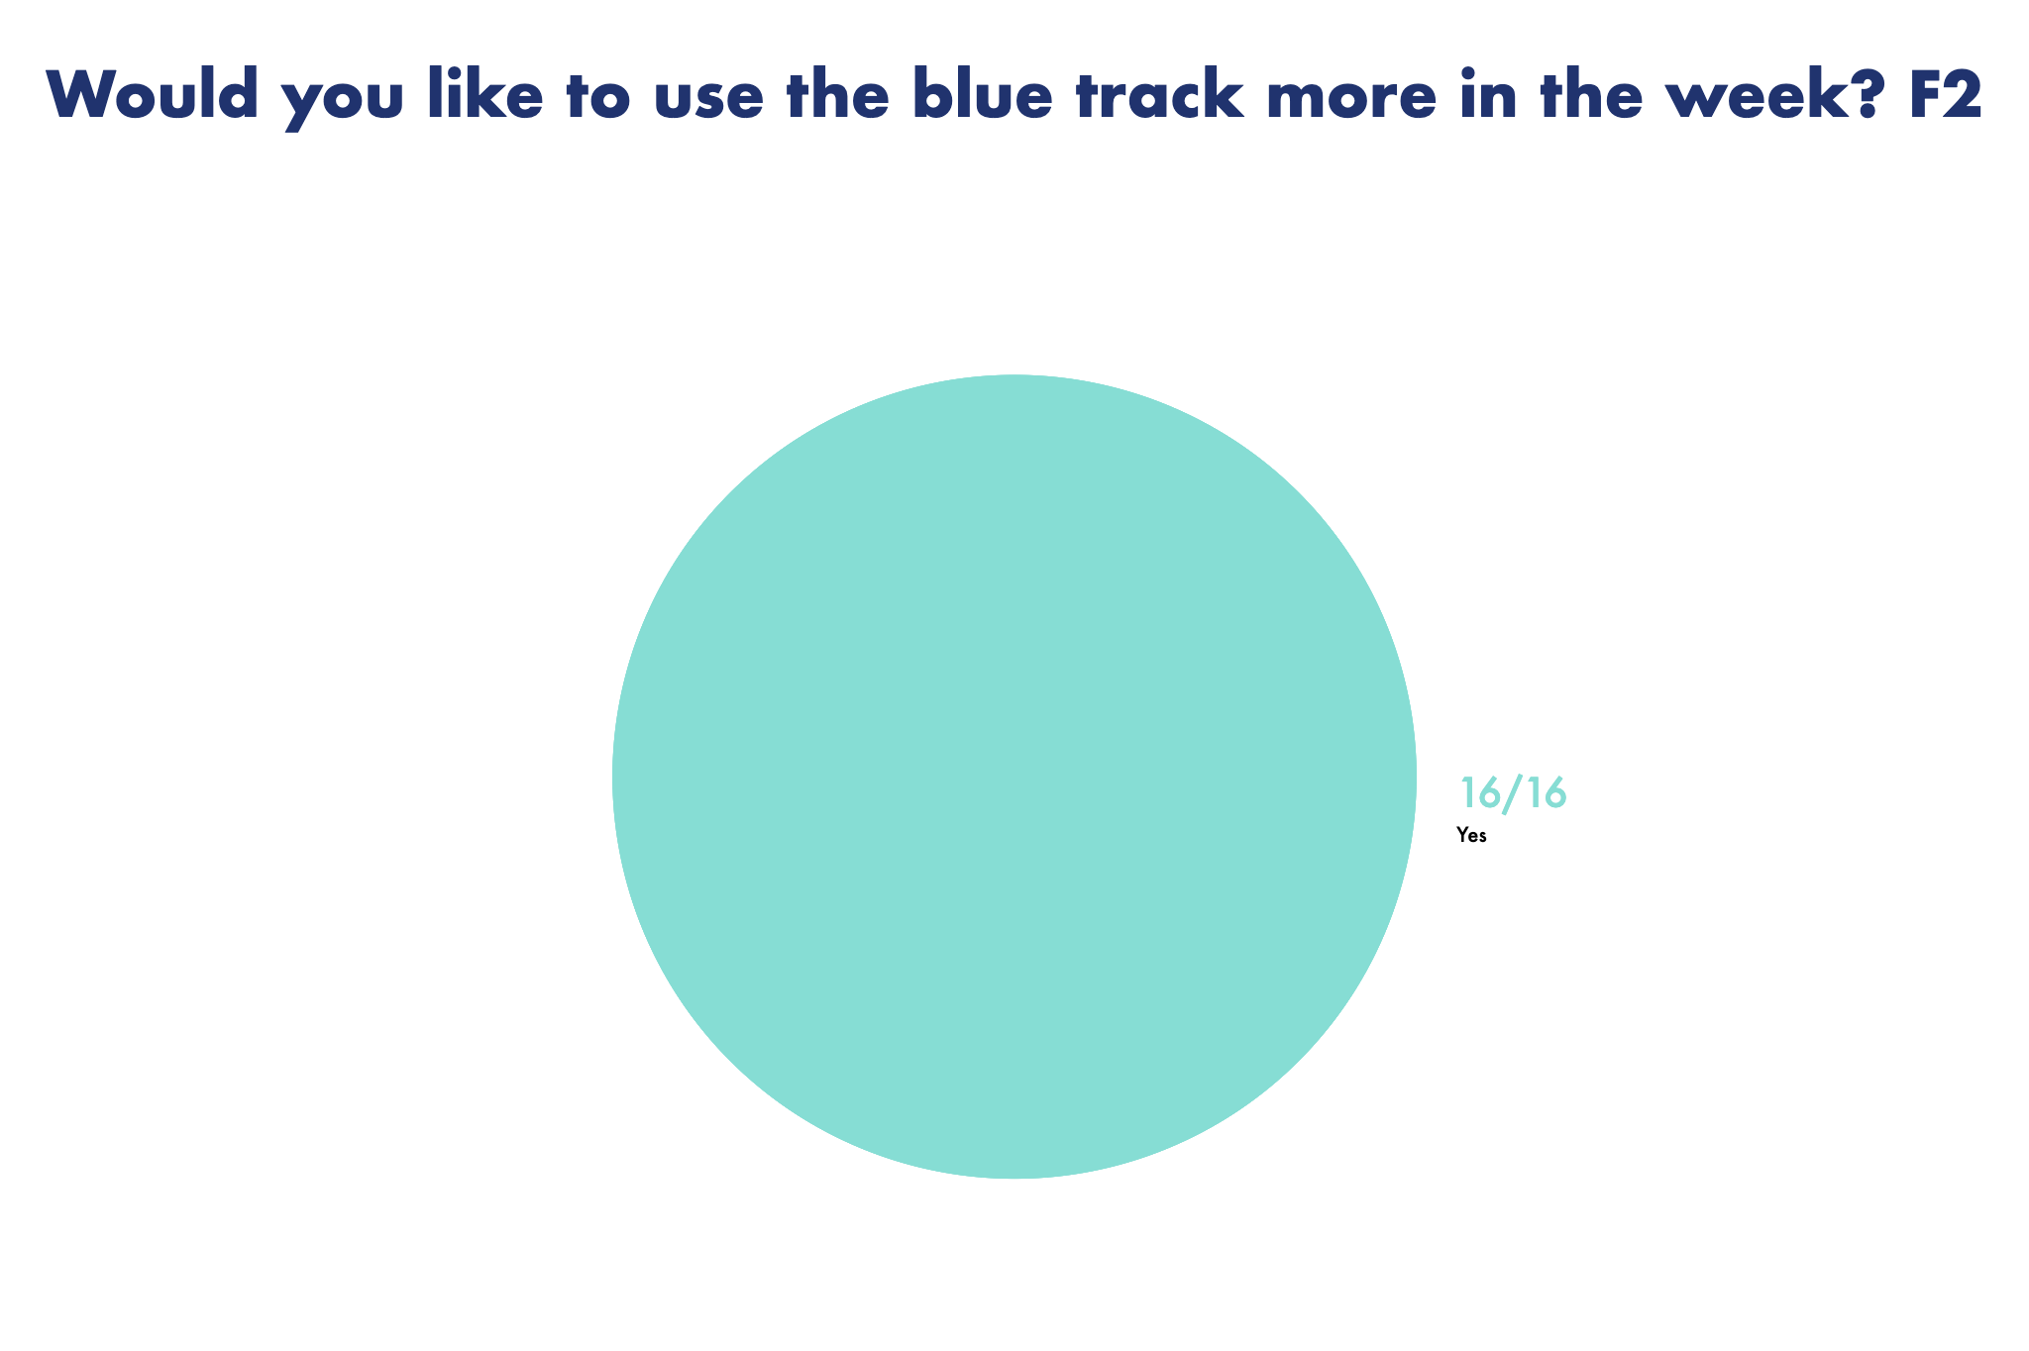
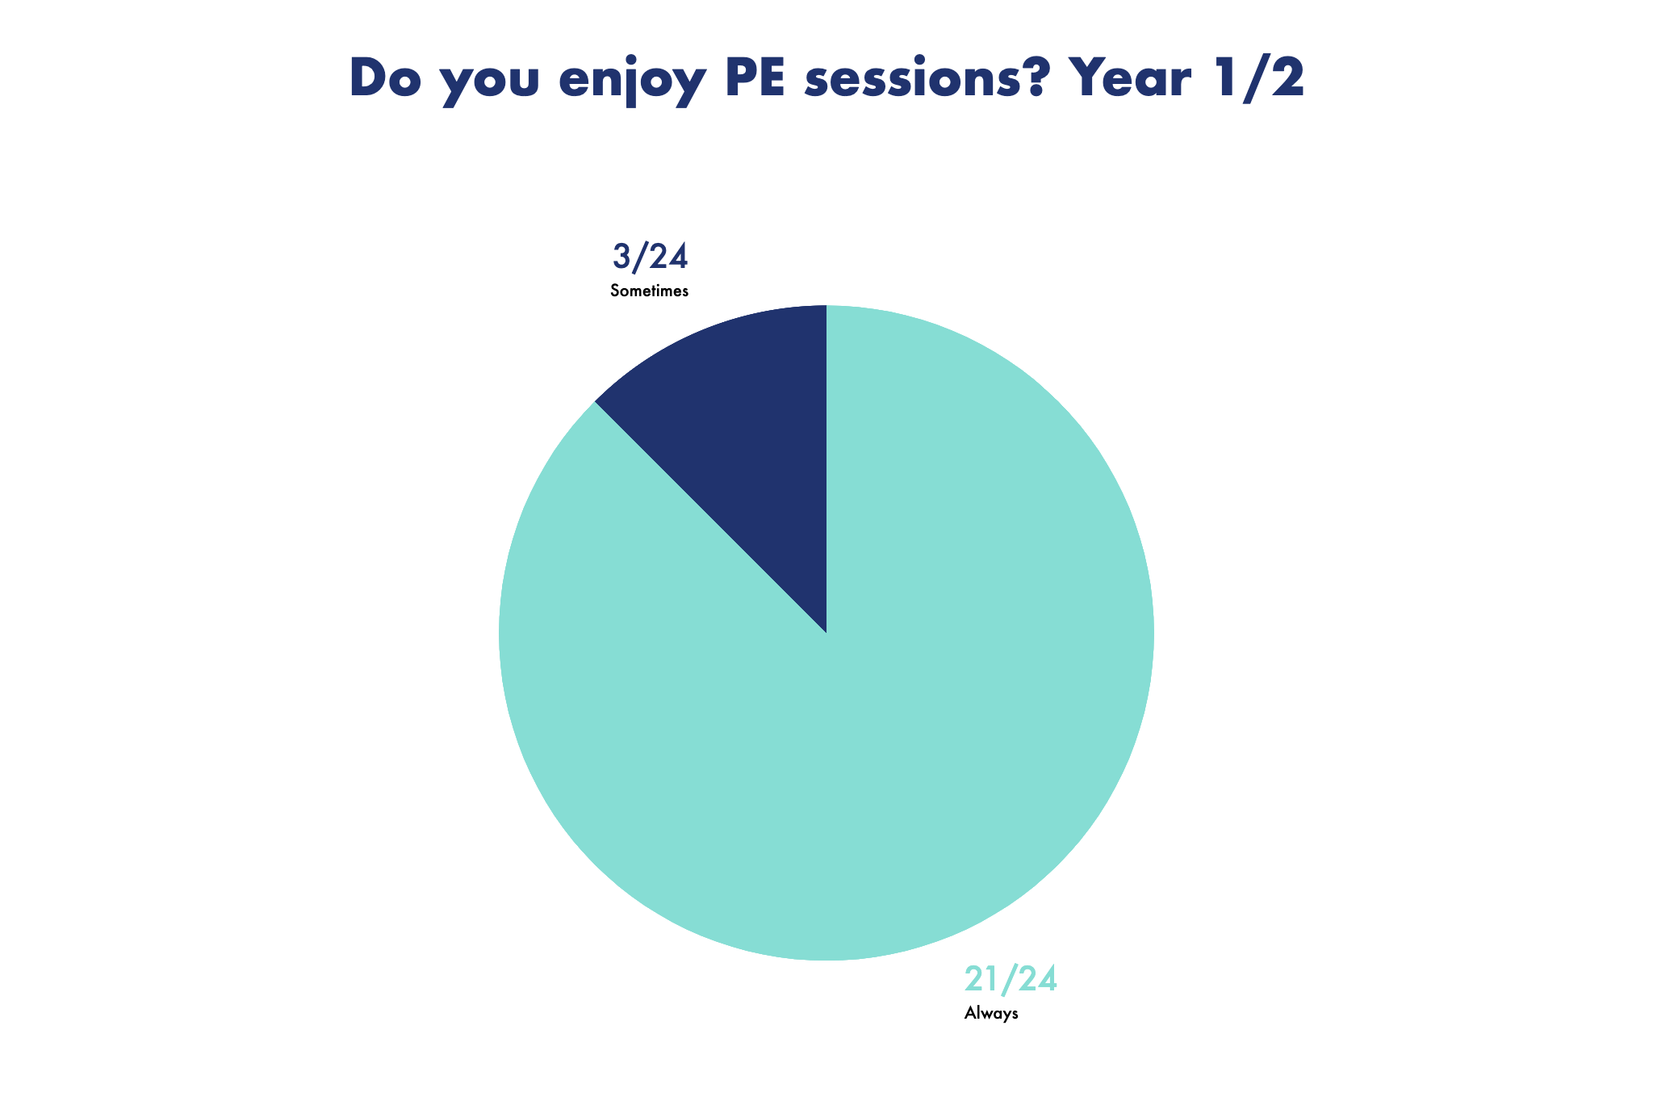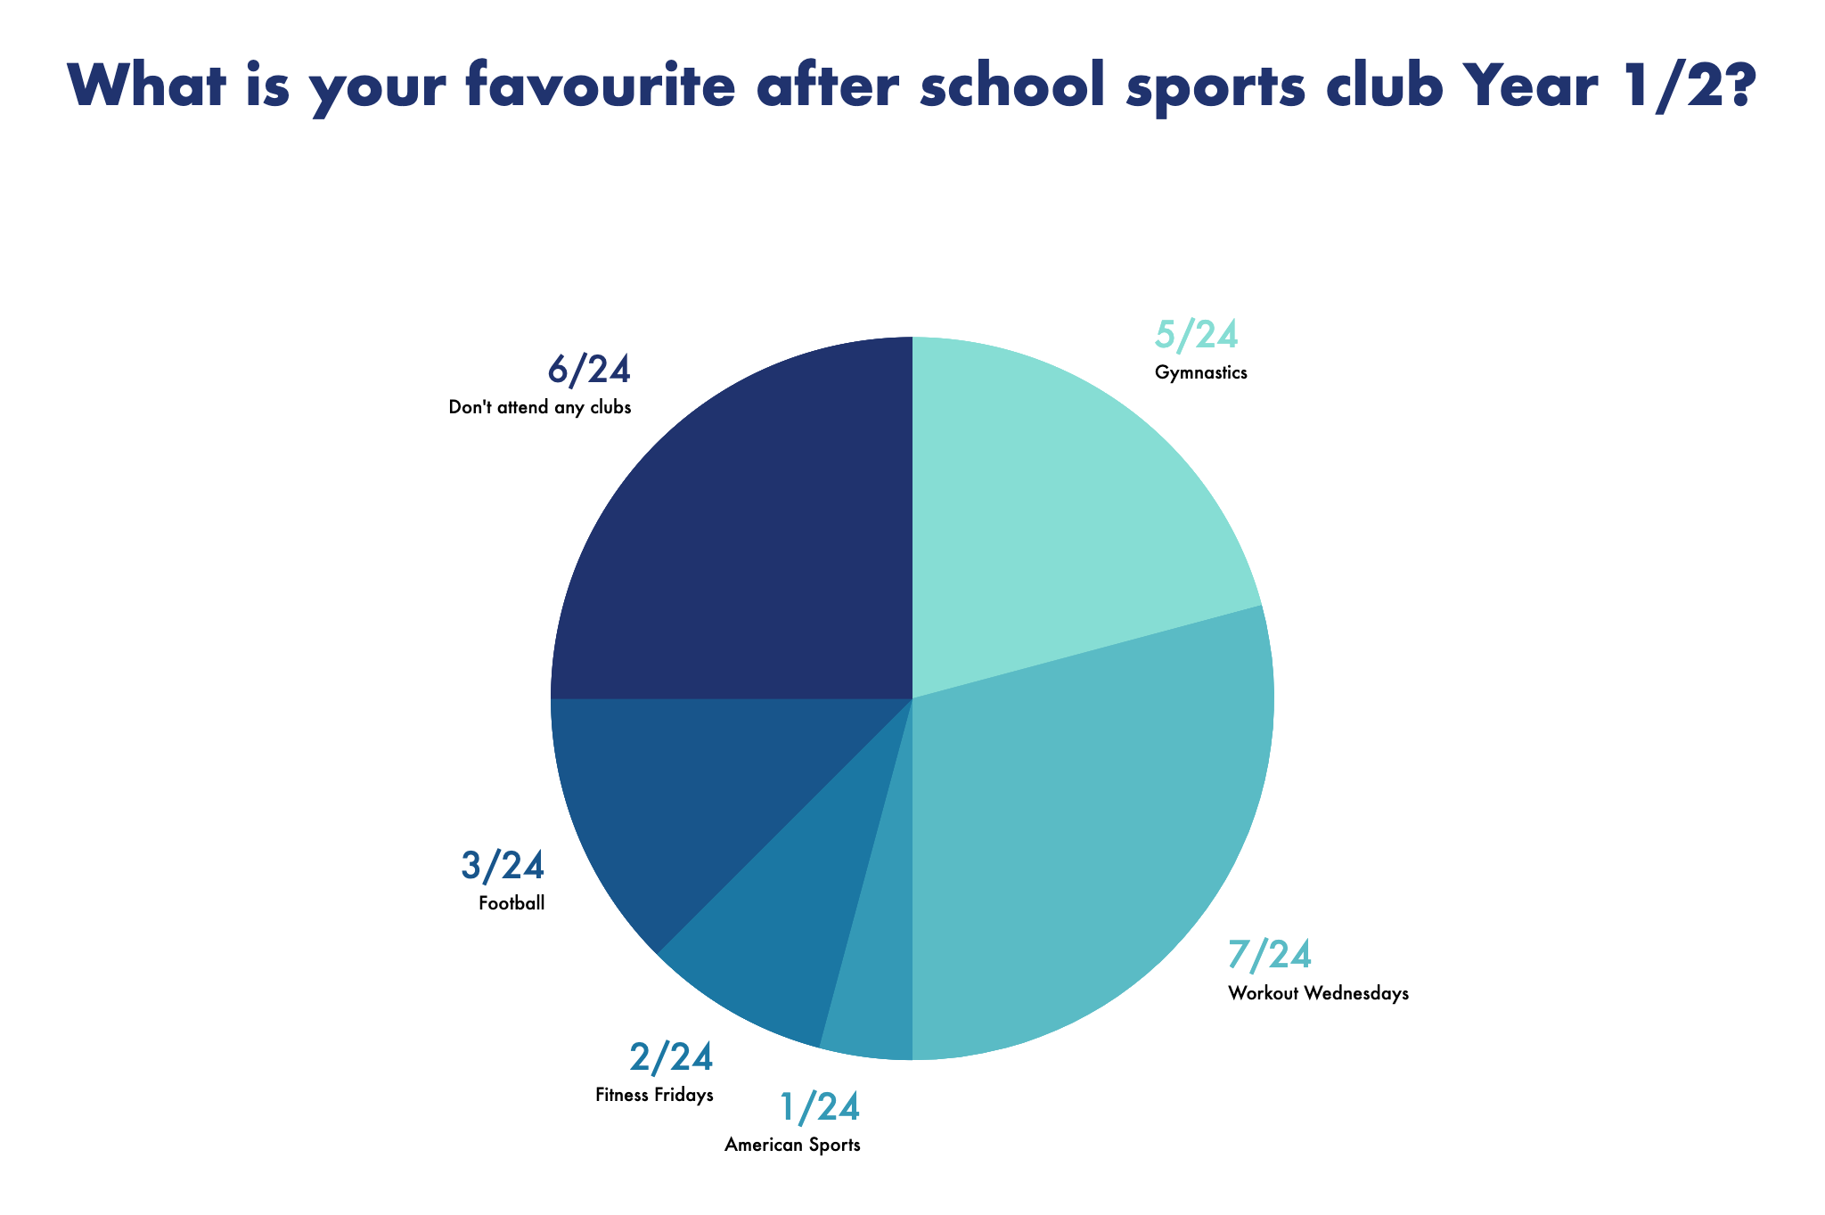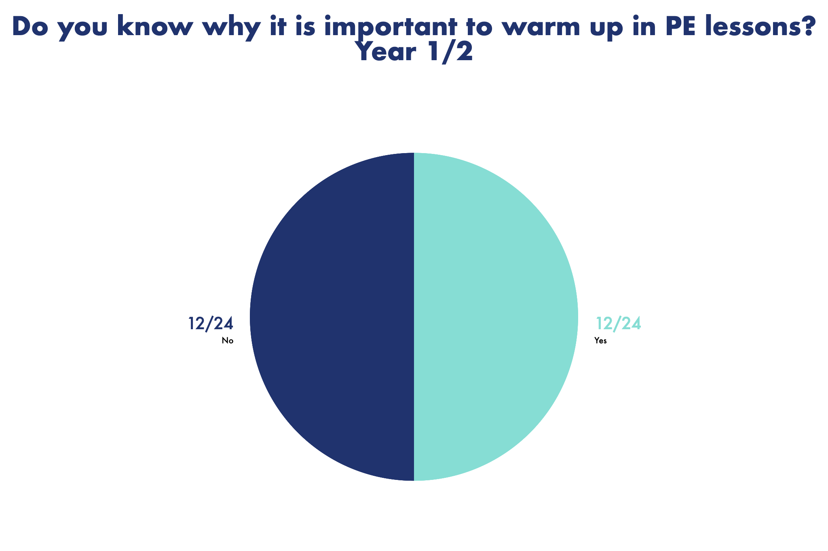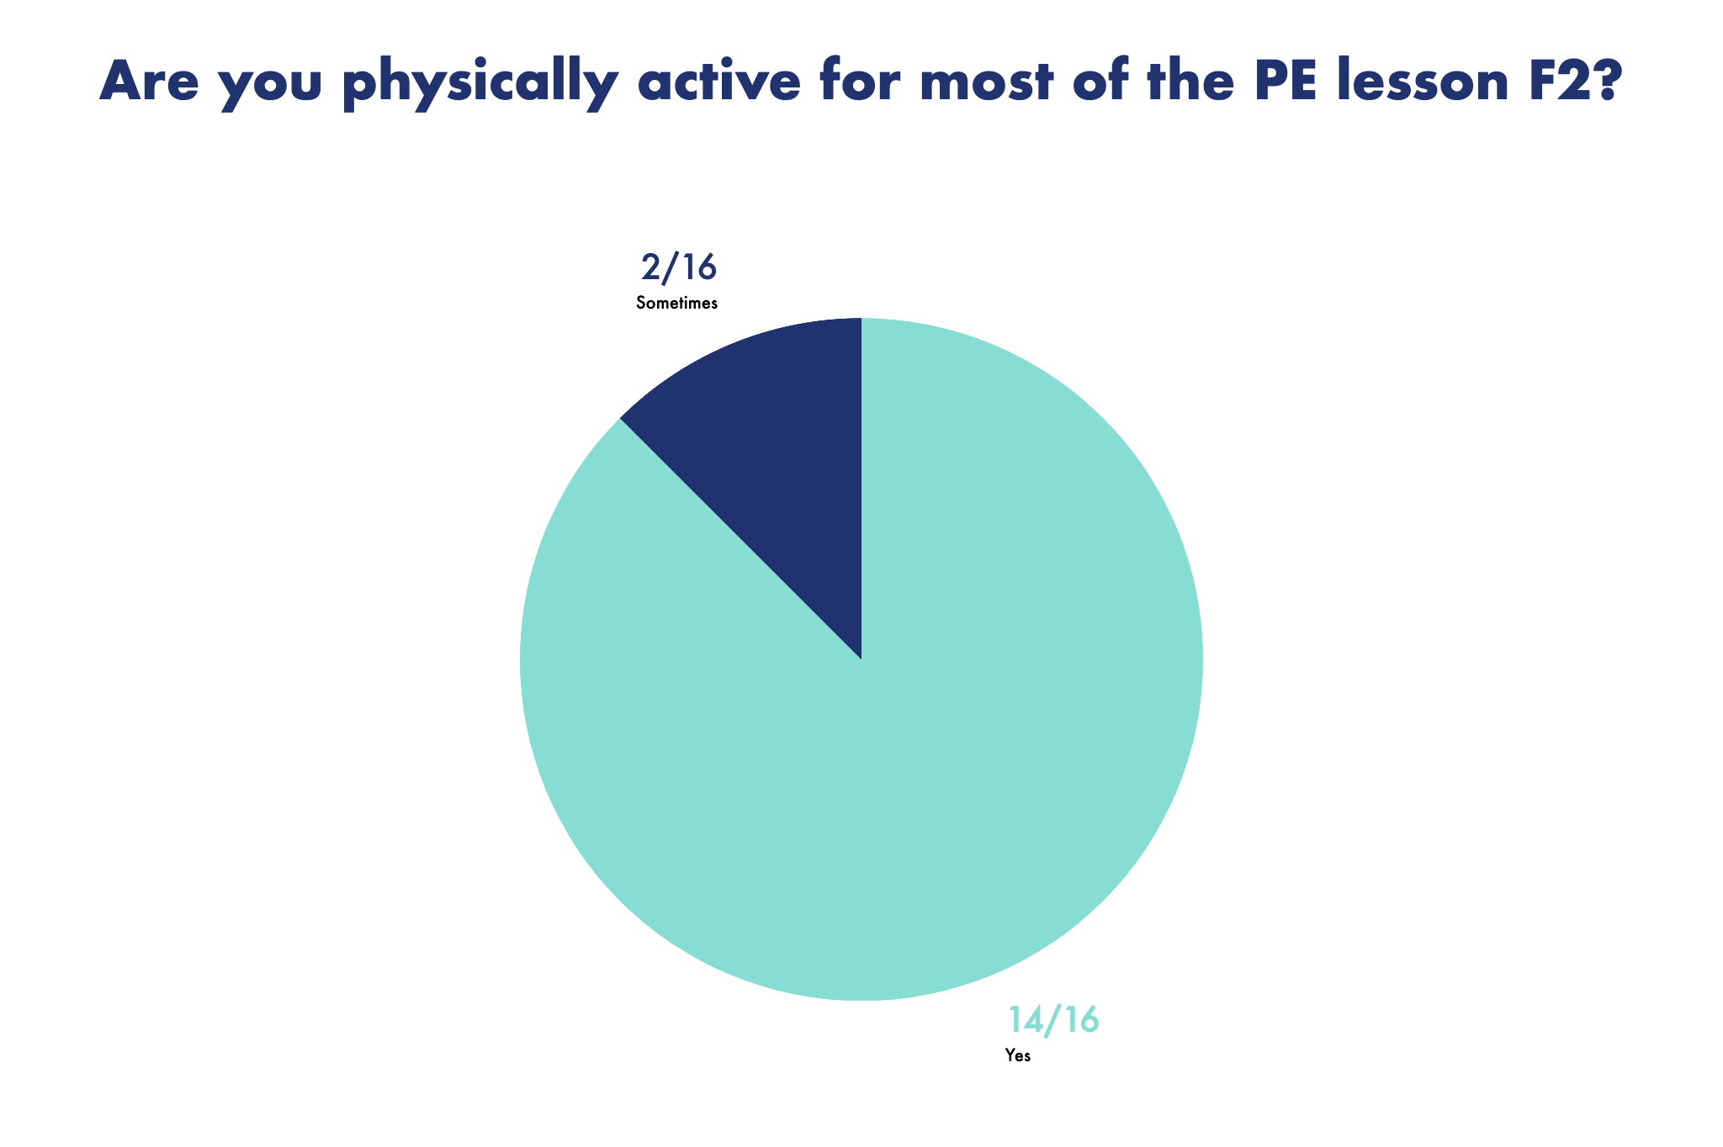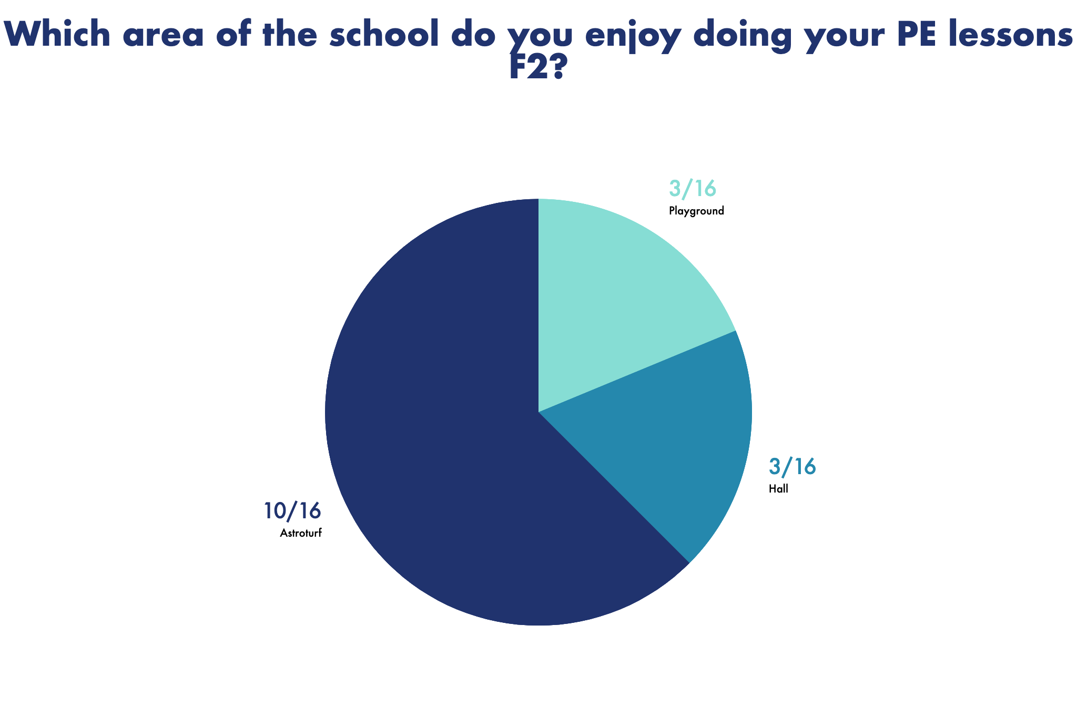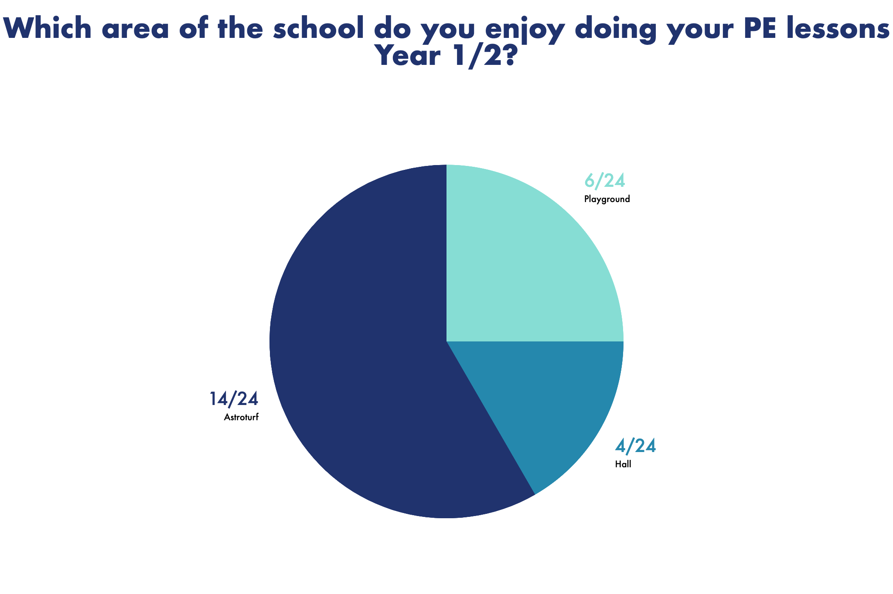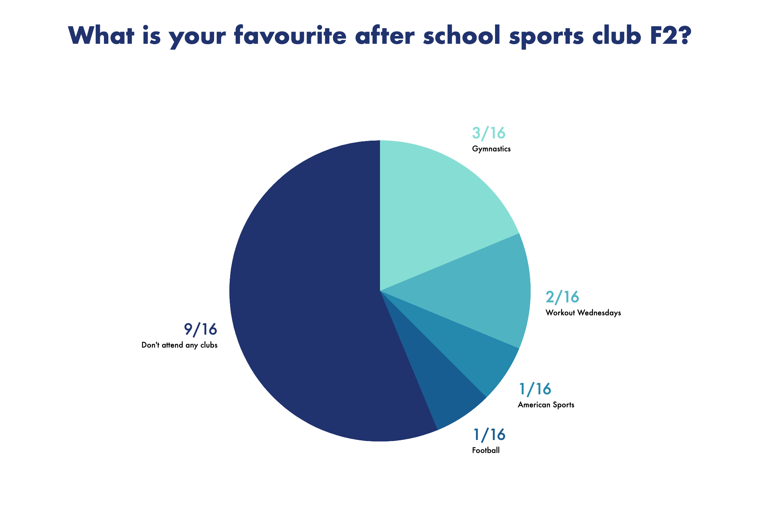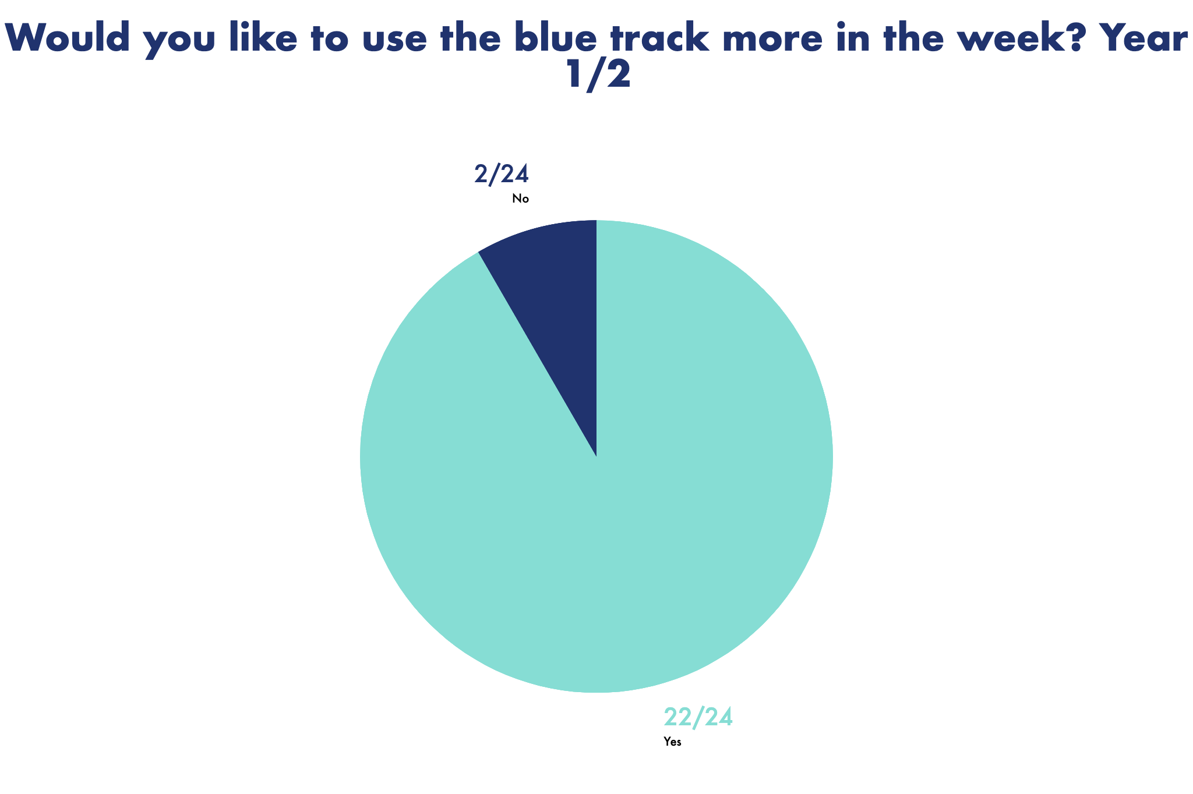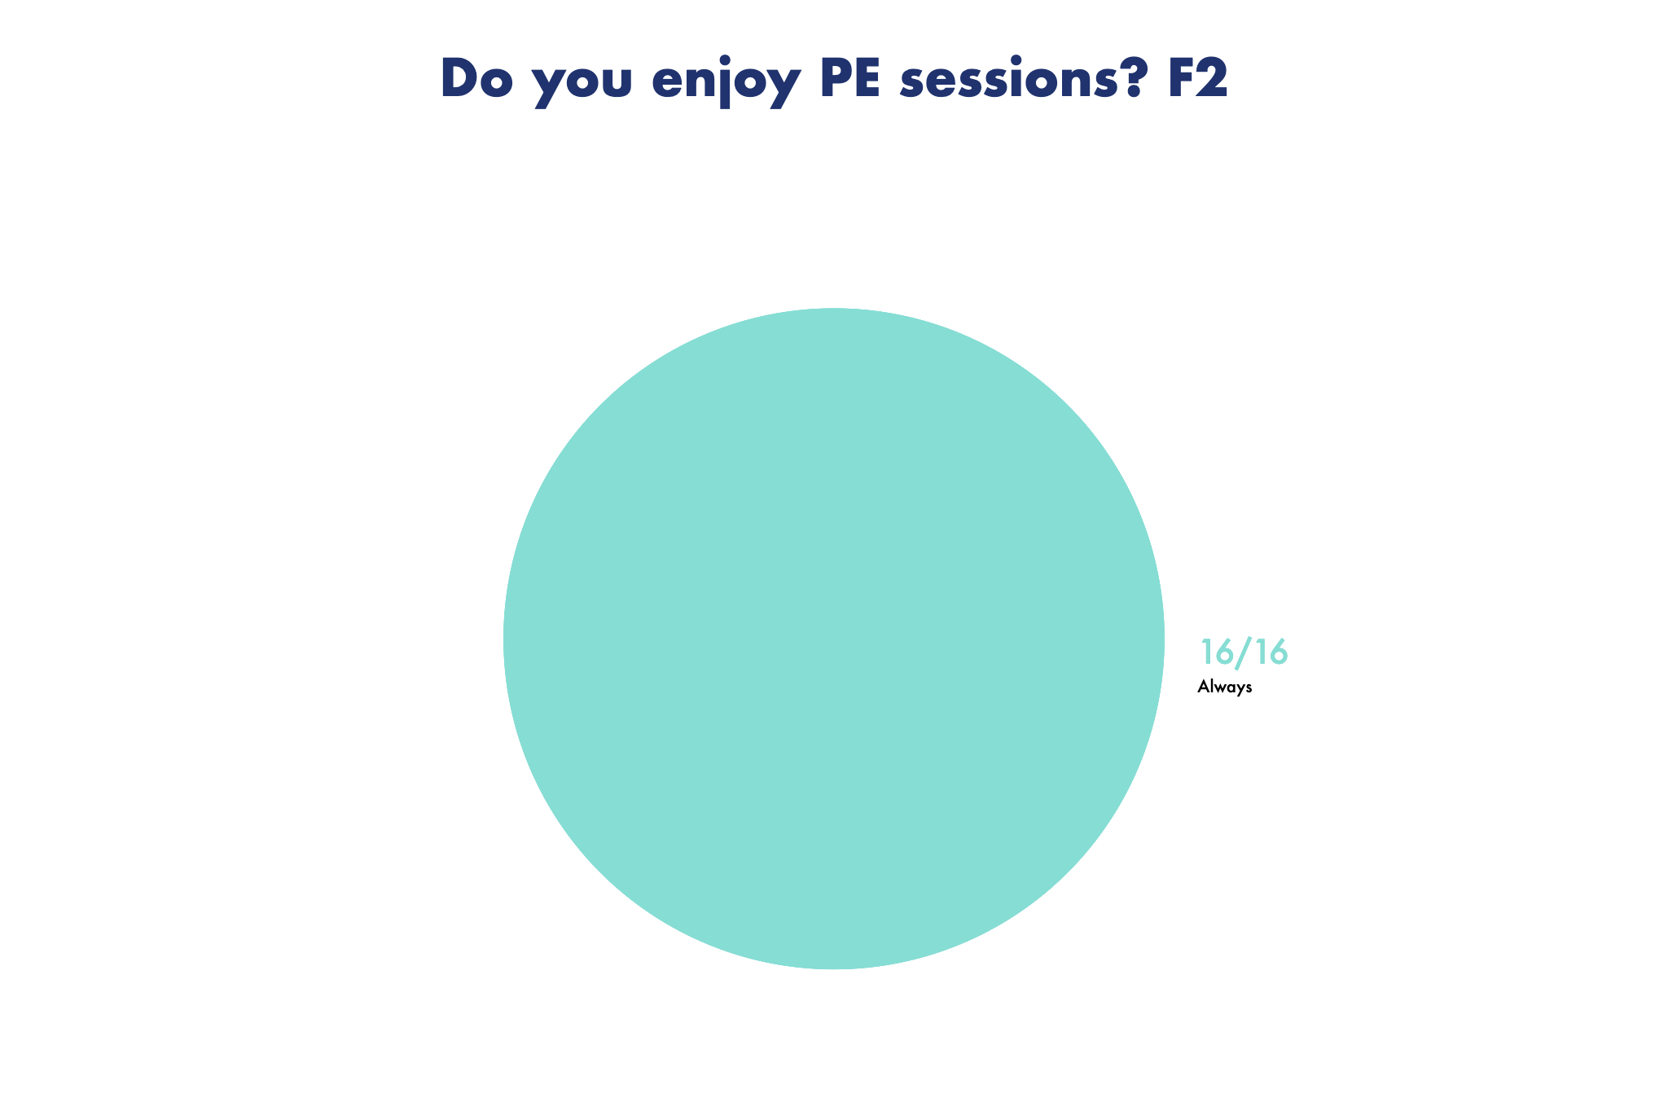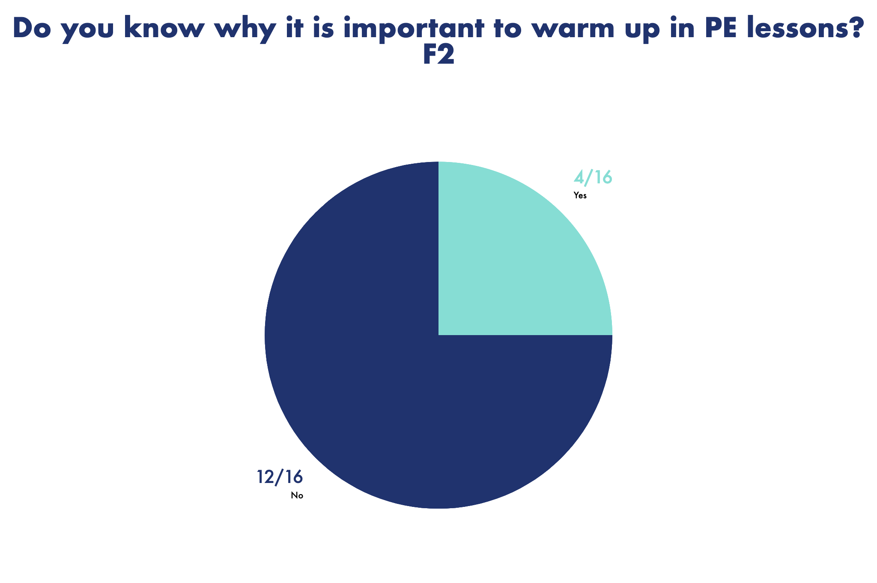

From the analysis of this collected data from the pupil PE questionnaires I have made several conclusions

- 100% of the sample of children in F2 and 92% of the sample of children in Year 1/2 said that they would like to use the blue track more. Therefore we will look to use the mile track with greater frequency in the future. This will enable children to increase their fitness and stamina.
- The data from the sample of children clearly shows that the children always enjoy their PE lessons and the majority of children always feel confident.
- The data identifies the need to recap on why it is important to warm up before physical activities.
- It can be seen from the data collected that the PE lessons are very successful in keeping children active and engaged in physical activities throughout the sessions.
- The Gymnastics after school Sports club is the most popular for the children in F2 and Workout Wednesday sessions are the favourite for the children in Year 1/2.
- There is a clear indication that children would like to participate in a new Basketball club if it was available at the school.
- A significant proportion of the children prefer to do outdoor PE sessions and in particular on the AstroTurf.

