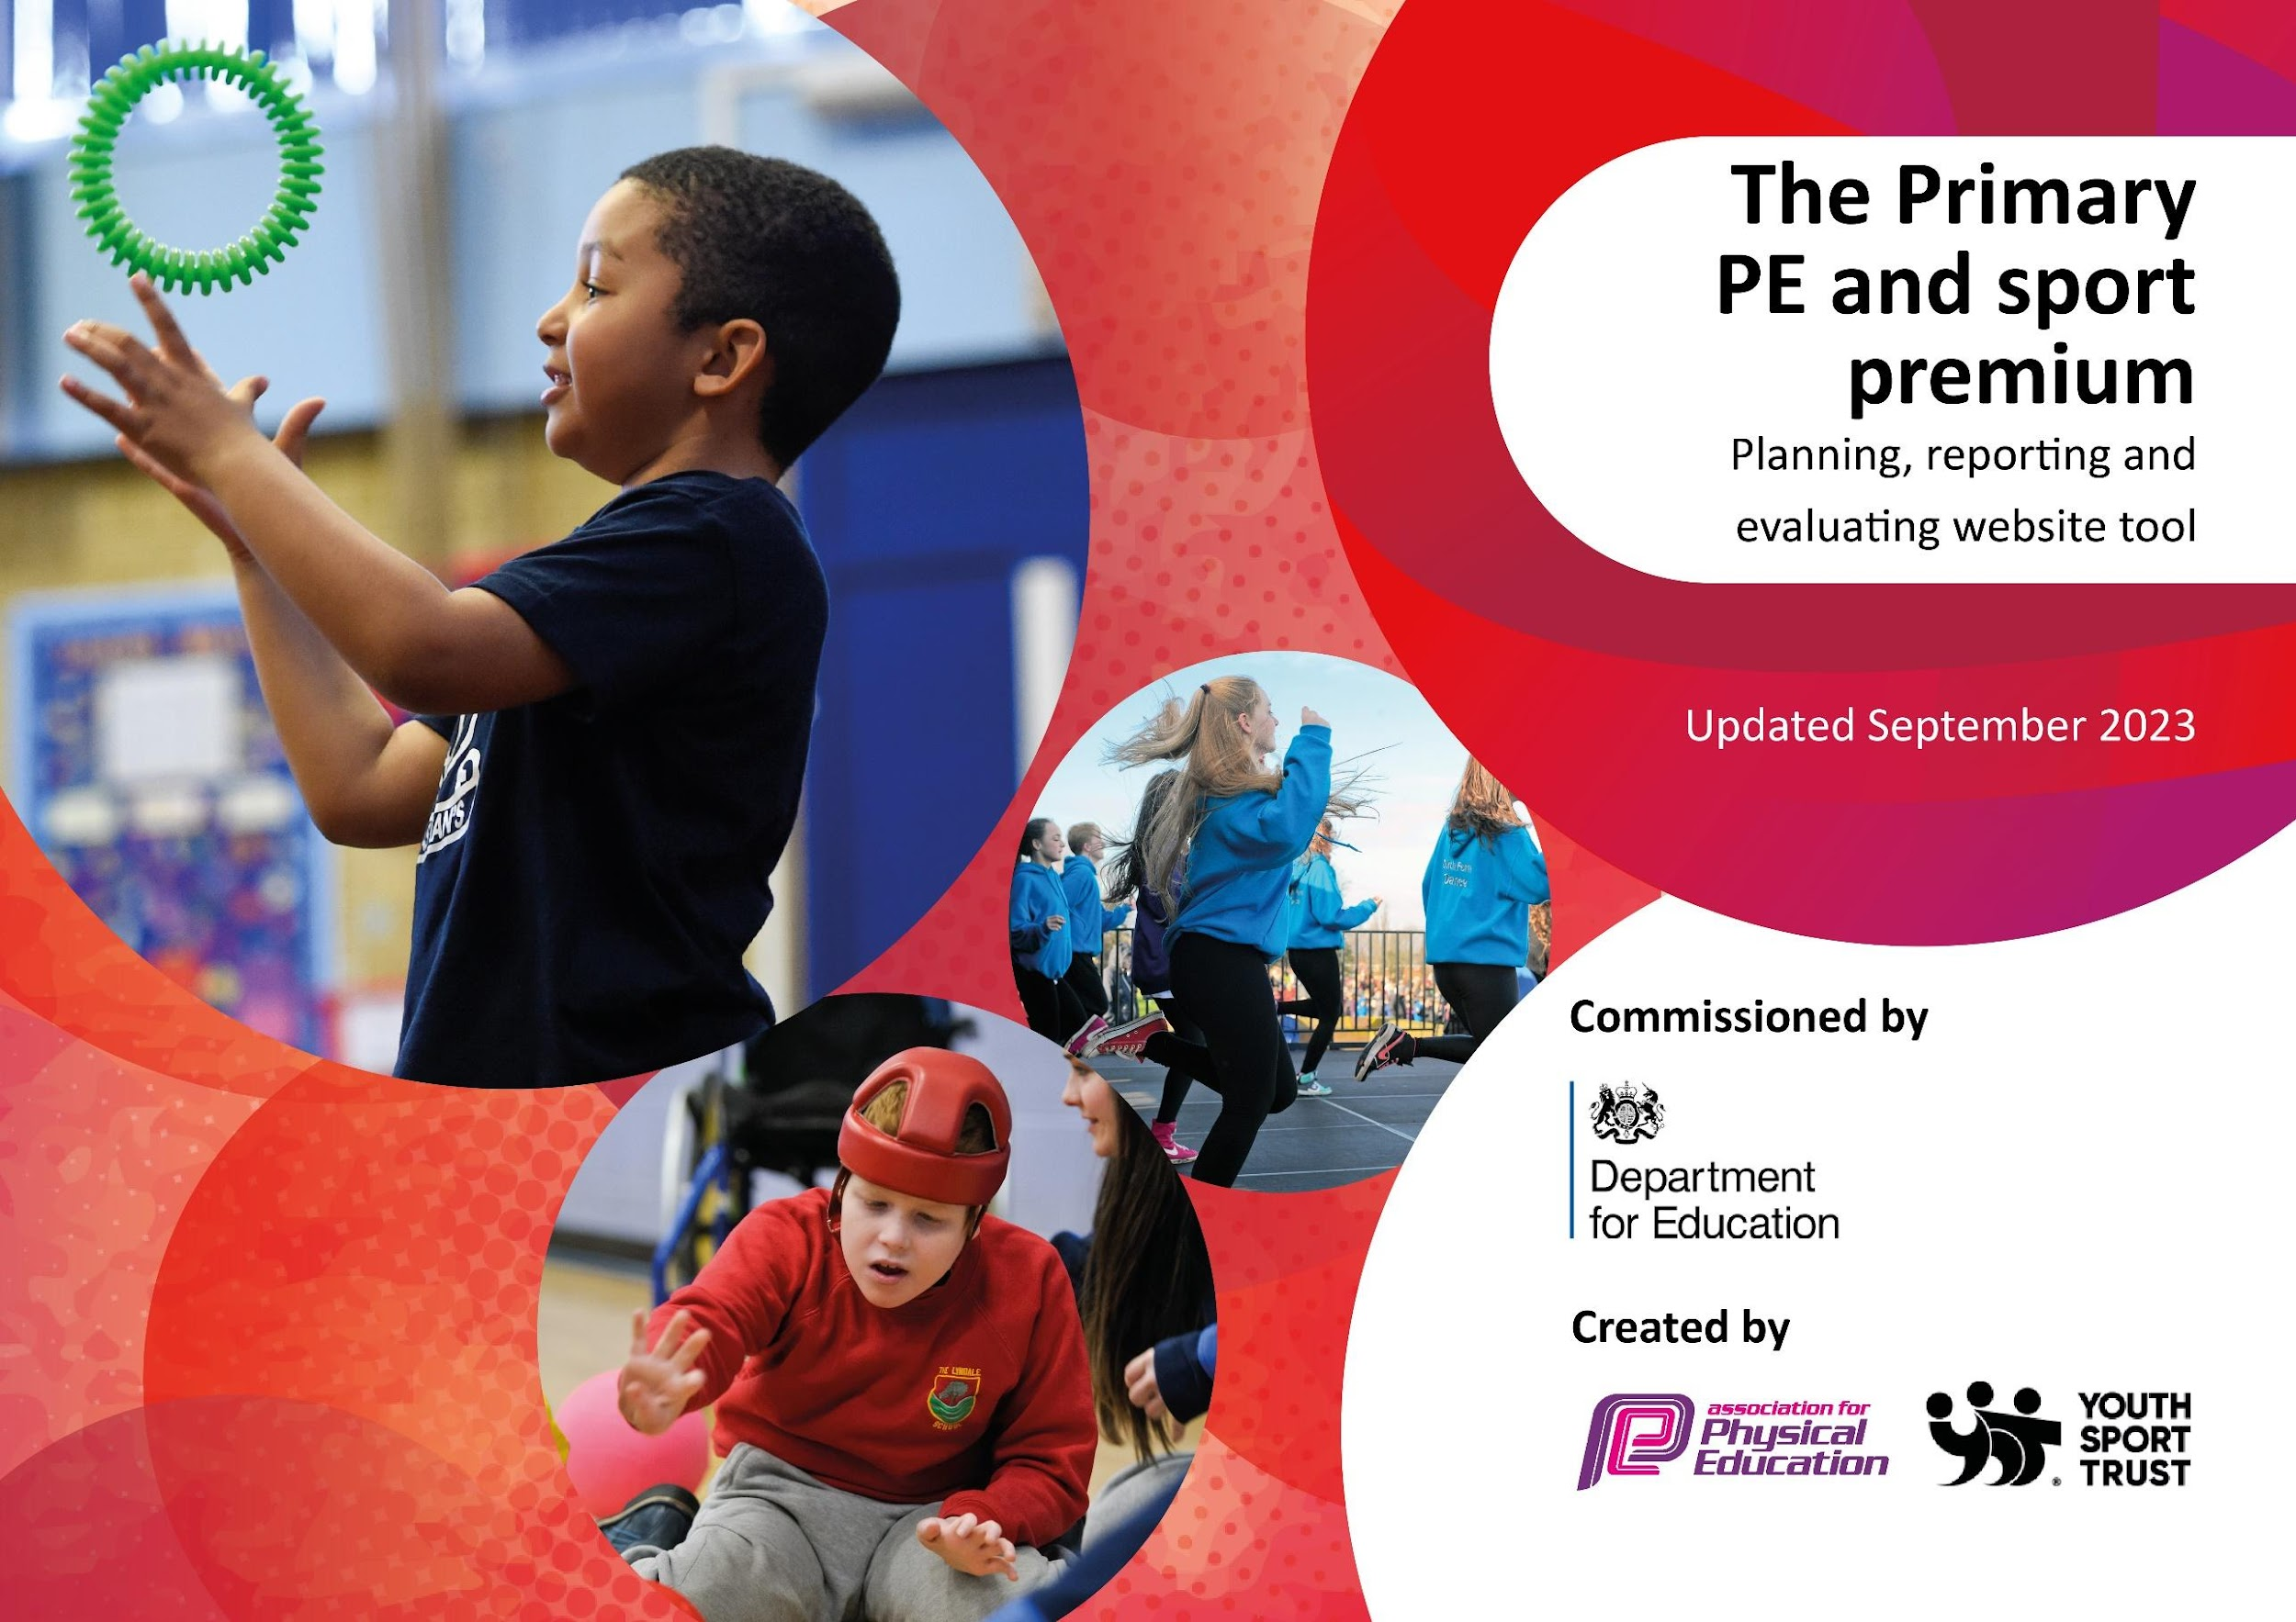

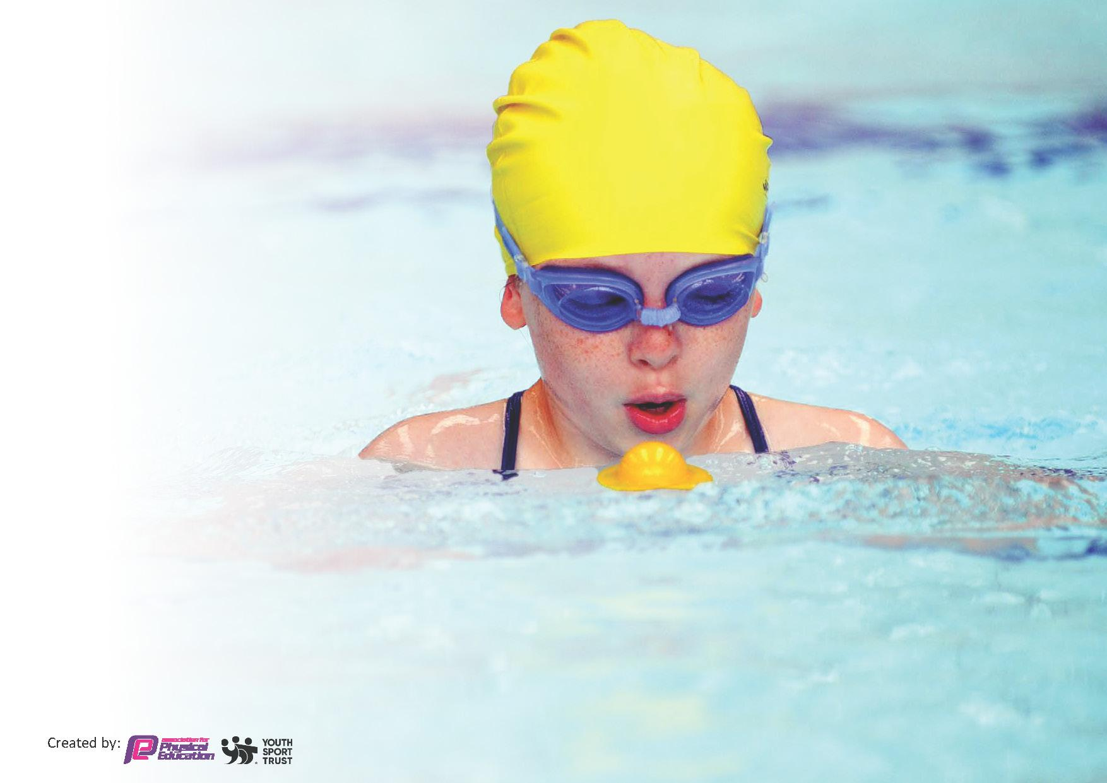
This template can be used for multiple purposes:
by:
- It enables schools to effectively plan their use of the Primary PE and sport premium
- It helps schools to meet the requirements (as set out in guidance) to publish information on their Primary PE and sport premium
- It will be an effective document to support Ofsted inspections enabling schools to evidence progress in Physical Education (PE) and evidence swimming attainment, which forms part of the PE National Curriculum. We would recommend schools consider
the Intent, Implementation and Impact of any spend, as examined within the Education Inspection Framework.

It is important that your grant is used effectively and based on school need.

Schools must use the funding to make additional and sustainable
improvements to the quality of the PE, School Sport and Physical Activity (PESSPA)
they offer. This means that you should use the Primary PE and sport premium to:

- Build capacity and capability within the school to ensure that improvements made now will benefit pupils joining the school in future years
- Develop or add to the PESSPA activities that your school already offers.

The Primary PE and sport premium should not be used to fund capital spend projects; the school’s core budget should fund these. Further detail on capital expenditure can be found in the updated Primary PE and sport premium guidance.

The Primary PE and sport premium guidance, outlines 5 key priorities that funding should be used towards. It is not
necessary that spending has to meet all the key priorities, you should select the priorities that you aim to use any funding towards.

Although completing this template is not a requirement for schools, schools are required to publish details of how they spend this funding. Schools must also outline what the impact this funding has had on pupils’ PE and sport participation and attainment and how any spending will be sustainable in the future. All funding must be spent by 31st July 2024.

The Department for Education has worked closely with the Association for Physical Education (afPE) and the Youth Sport Trust (YST) to develop this template and encourages schools to use it. This template is an effective way of meeting the reporting requirements of the Primary PE and sport premium.
Review of last year’s spend and key achievements (2022/2023)

We recommend you start by reflecting on the impact of current provision and reviewing your previous spend.

Activity/Action | Impact | Comments
Commitment to KS2 swimming blocks Y3-6 every year and Y6 end of KS2 competent 25 metre swimmers with good strokes has risen from 95%+ to 98%+ due to this commitment.  Many competitive sports events throughout the year.  Children taking part in a wide range of after-school sports clubs.  Staff CPD in order to make sure that the 2 hour/week provision of PE and Games is high quality.  Continuation of the school mile and engagement with this once per day and varied sporting activities.  All-weather pitch and adventure play used at all play and lunchtimes with bespoke activity on the all-weather pitch increasing activity.  A new all-weather pitch was built and used to increase physical activity at break times and during lessons. | When children leave school in Year 6, they leave as confident and competent swimmers who can swim 25metres and know basic skills to help them if they are in danger.  Children are taking part in more competitive sports across the year and more children in the lower years are able to access these competitions too.  Children have a better understanding of a wide range of sports (judo, archery, taekwondo, gymnastics, American football, football, etc.)  Staff are more confident with delivering PE lessons and have learnt new skills which have impacted PE lessons.  More children are actively engaging with the daily mile line and understand the importance of regular physical activity.  Children are able to utilize this space to ensure no matter the weather they have a space to play games and be active.  New all-weather pitch built to focus on sports other than football for children to try new skills and sports at break times and in lessons. | Swimming was very effective and it was also good for the pupils’ mental health and well-being as well as the standard of swimming that was achieved.  Children love the competition across schools.  A wide range of clubs which are again good for overall fitness and good for mental health. We did attempt to gain some KS1 clubs but most are reluctant to take KS1 as they then have to pay extra staff as they say they cannot take them on their own as our school sports provider can.  This remains a very good strategy and good use of it is made.  The two all weather pitches have been a real asset to the amount of on-going sport throughout the day that can take place and during the holidays also with our sports provider.

Key priorities and Planning
This planning template will allow schools to accurately plan their spending.

Action – what are you planning to do | Who does this action impact? | Key indicator to meet | Impacts and how sustainability will be achieved? | Cost linked to the action
Purchase new PE equipment to be used in lessons.  Purchase new equipment for break times to increase children’s exercise opportunities.  To have bike-ability in school to teach children how to ride a bike safely on the road.  To teach children to become play monitors to be used at playtimes to increase children’s exercise.  CPD for staff through the national college and other appropriate providers.  To purchase books to be used in classroom libraries to promote sport and a range of athletes, some of whom have disabilities.  To continue to work with specialist coaches and visitors to raise the profile of PESSPA and to increase the range of sports available. (online if necessary)  To ensure that the curriculum is rich with healthy activity opportunities across all subjects (health week) Develop the use of digital mapping tools to keep pupils active around the school grounds and beyond  To continue the high profile of competitive sports – inspiring team work and engagement in competing.  To continue afPE school membership to ensure access to specialist and expert support, thus keeping the school fully up-to-date.  To provide further opportunities for children to access physical activity at break times with a developed area in KS1  To develop and buy outdoor equipment for F2. | Children  Children  Children  Children  Staff and Coaches  Children  Staff  Staff  Children  Staff and coaches  Children  Children | Key indicators 2, 4 and 5  Key indicator 2  Key indicators 2 and 3  Key indicator 2  Key indicator 1  Key indicator 3  Key indicator 3  Key indicator 3  Key indicator 5  Key indicator 1  Key indicator 2  Key indicators 2 and 3 | This will support children in their learning of different skills and new sports and will further actively engage them with PE lessons and physical activity. Continue monitoring of PE resources for wear and tear and replace as necessary.  Children more engaged and playing co-operatively at playtimes. Gross motor skills developed. Continue monitoring of PE resources for wear and tear and replace as necessary.  Children will learn basic road safety skills, as well as being able to ride a bike. Continue to invite bikeability in each year for children to learn essential skills with riding a bike.  Children to become more active with a wide variety of equipment and learning of new games. Continue to train children a variety of games for them to teach to other children.  Staff will be more confident to try new games and activities in lessons and will learn new techniques.  Children will learn about famous athletes and any issues they have overcome. Children will become more interested in reading. Continue to add new titles each year.  To provide PE lessons for staff, school games and events. Continue to develop more competitions in school and with other schools  Children to learn healthy habits with eating and why exercise is important. Continue each year with different activities.  Children to learn how to play competitively with other children from different schools. To look for further opportunities to develop competitions in different sports with local schools.  Staff will be able to access online resources and support to help them deliver lessons. Continue to buy in to ensure staff can keep up to date with the latest news.  Children will become more active at break times and will develop better attitudes to physical activity. Their gross motor skills will develop.  Children to develop their PD skills: gross and fine motor skills when using outdoor equipment. | £1,500  £1,000  Free  Free  Free  £800  Free  £2,000  £60 for digital mapping license  £200  £115  £10,000  £3,000  Amount of Sports Premium = £18 675  Total spend = £18 675

Key achievements 2023-2024
This template will be completed at the end of the academic year and will showcase the key achievements schools have made with their Primary PE and sport premium spending.

Activity/Action | Impact | Comments

Swimming Data
Meeting National Curriculum requirements for swimming and water safety.
Priority should always be given to ensuring that pupils can perform safe self-rescue even if they do not fully meet the first two requirements of the National Curriculum programme of study

Question | Stats: | Further context  Relative to local challenges
What percentage of your current Year 6 cohort can swim competently, confidently and proficiently over a distance of at least 25 metres? | % | Use this text box to give further context behind the percentage.  e.g., 30% - we are struggling to get pool space due to our local pool closing so we have had to use a much smaller local school pool. We have had to limit the number of pupils attending swimming lessons during one term which means some pupils have attended fewer swimming lessons than others.
What percentage of your current Year 6 cohort can use a range of strokes effectively [for example, front crawl, backstroke, and breaststroke]? | % | Use this text box to give further context behind the percentage.  e.g., Even though your pupils may swim in another year please report on their attainment on leaving primary school at the end of the summer term 2024

What percentage of your current Year 6 cohort are able to perform safe self-rescue in different water-based situations? | % | Use this text box to give further context behind the percentage.
If your schools swimming data is below national expectation, you can choose to use the Primary PE and sport premium to provide additional top-up sessions for those pupils that did not meet National Curriculum  requirements after the completion of core lessons. Have you done this? | Yes/No
Have you provided CPD to improve the knowledge and confidence of staff to be able to teach swimming and water safety? | Yes/No

Signed off by:

Assistant Head Teacher: | Martin Pipe
Subject Leader or the individual responsible for the Primary PE and sport premium: | John Jones/Jill Pearson/Martin Pipe
Governor:
Date:

